Beating Misinformation Starts in Your PR Newsroom
Teis Meier

Why misinformation thrives, and why it’s your problem now
It’s no surprise that 63% of a company’s market value is driven by reputation. But reputation has never been more fragile.
Social platforms amplify speculation before facts can catch up. Newsrooms publish fast; corrections come later. Add in AI-generated content, political polarisation, and fragmented audiences, and misinformation becomes a constant risk, especially for multinational brands.
As Presspage Co-Founder Bart Verhulst puts it:
“Communicators today are operating in environments with multiple markets, multiple brands, and audiences that use completely different channels and formats. It makes the life of the modern communicator quite a difficult one.”
The result? Even small missteps can trigger global ripples.
In late 2022, a Twitter account masquerading as multinational pharmaceutical giant Eli Lilly announced that “insulin is free now.” The post, verified with a blue checkmark under Twitter’s new paid system, tanked the company’s stock by 4.37%, roughly $15 billion in market value.
It took 48 hours of confusion and a series of newsroom-led corrections to stabilise the narrative.
Eli Lilly did one thing right: they anchored every update to a single verified newsroom URL and briefed journalists to cite it as the official source. It’s a perfect example of what a newsroom-first response looks like in practice.

1. Spotting false narratives before they spread
Human nature is wired for curiosity and fear, which is why misinformation moves six times faster than the truth. We’re drawn to what feels urgent, emotional, or risky, and those are exactly the signals that trigger viral spread.
But not all false information is created equal. Understanding the four information types helps comms teams know what they’re up against:

News Type | True/False | Intent | Example
Real News | True | Positive | Corporate or product announcement
Malinformation | True | Negative | Leaked data shared out of context
Misinformation | False | Positive | Inaccurate info shared unintentionally
Disinformation | False | Negative | Deliberate attempt to mislead

Disinformation, in particular, is often weaponised. In some geopolitical contexts, for example, state-backed media interference, it’s an intentional strategy to shape markets and public opinion. Once that falsehood hits mainstream or social channels, your team’s challenge is speed and verification.
“It’s crucial to monitor tone and detect emerging issues early,” says Verhulst. “The longer misinformation circulates unchecked, the harder it is to correct.”
What leading teams do:
- Maintain real-time monitoring dashboards to detect sudden spikes in newsroom traffic.
- Set up alerts for unusual referral traffic to brand domains, a potential signal that misinformation is driving search.
- Keep a rumour log: a simple shared doc that tracks potential narratives before they escalate.
This is the Sense Phase of the Crisis Lifecycle Framework, the stage where awareness determines control:
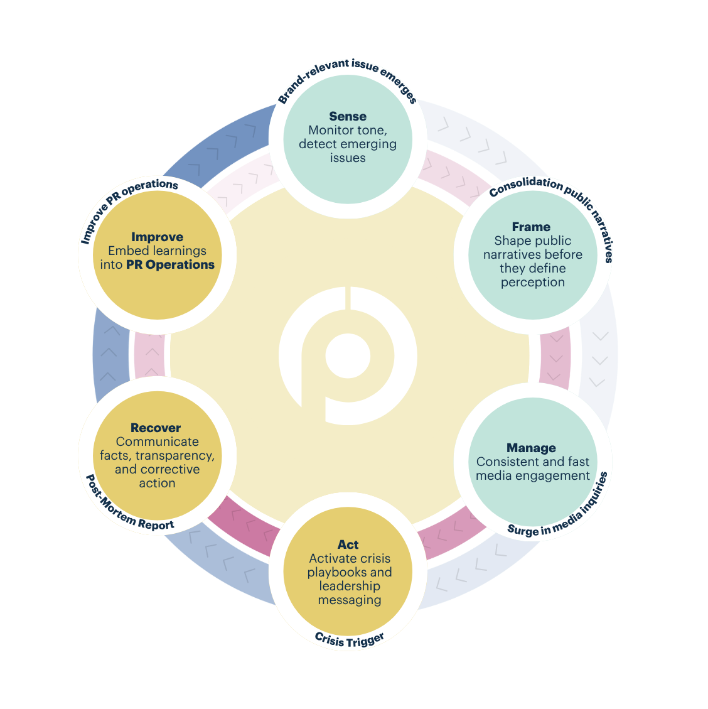
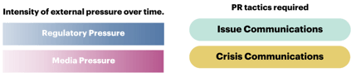

2. Publishing fast, fact-based responses
When a false story hits, the difference between damage control and narrative control is often measured in minutes.
The golden rule: publish the correction before the first misinformation post hits its second or third wave of shares.
Case in point:
- In 2016, a fake press release announcing the resignation of Vinci’s CFO wiped €7 billion off its market value in minutes before the company issued a correction.
- Not long before this, a spoofed G4S email triggered a €46 million dip before recovery.
- A forged Bloomberg page once reported a fictitious Twitter buyout, spiking the stock by 8% before being debunked (BBC, 2015).
These weren’t minor digital pranks; they were high-speed manipulations of financial information, often tied to pump-and-dump schemes.*
*Fraudulent manipulation of information to create a buying frenzy that will “pump” up the price of a stock so shady parties can “dump” shares of the stock by selling at the inflated price.
Each shows why owning your channels is critical.
“You can’t always stop spoofing,” Verhulst explains, “but you can build digital fingerprints, always link back to your official newsroom and make sure your newsroom publishes at the same time as your release.”
That’s the playbook Eli Lilly followed: within hours, their newsroom became the definitive point of reference. Once journalists and analysts had one trusted URL to cite, misinformation lost momentum.

The anatomy of a fast, credible response
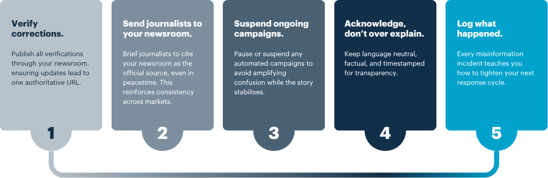

3. Tracking how your story travels
Restoring trust doesn’t stop once your correction is live. The next 48 hours are critical for understanding whether the truth actually landed.
This is where many teams lose visibility. Without integrated publishing and analytics, it’s hard to know which journalists picked up your correction, how many readers reached your newsroom, or whether sentiment recovered.
The solution is simple in principle, harder in execution: measure your recovery.
Track:
- Referral patterns: Are inbound visits to your newsroom increasing from media sites or search engines?
- Engagement by geography: Where is your correction resonating, and where is misinformation persisting?
- Query analysis: What keywords or questions are people searching for after your statement?
These indicators reveal how your narrative travels and whether your “truth signal” is cutting through, when you can prove that, with data, you can justify future team and newsroom investments.
“Preparedness is process plus tooling,” says Verhulst. “When misinformation hits, that combination lets you act, not react.”

Crisis readiness isn’t just for crises
Rumours, leaks, and misinformation don’t always qualify as full-blown crises, but they can erode credibility if left unchecked. That’s why issue communications and crisis communications aren’t opposites; they’re two halves of the same system.
Crisis comms protects your reputation in the moment. Issue comms builds the credibility that carries you through it.
A newsroom-first strategy unites both. It gives your team a live, owned channel to:
- Publish verified information instantly
- Frame narratives before others do
- Archive updates transparently for media reference
The result: fewer dependencies, fewer delays, and a tighter grip on your reputation across every market and time zone.

How Presspage helps
When a story spirals, control comes from preparation and the right platform.
Presspage gives comms teams a single environment to manage every step of the misinformation response cycle:
- Publish: Launch verified updates directly from your branded newsroom, no IT dependencies.
- Reach: Send briefings and corrections to your journalist lists instantly.
- Connect: Manage incoming media inquiries in one shared inbox.
- Discover: Track reads, distribution, and referral patterns in real time.
From multinational corporations to listed companies, Presspage customers use these tools to ensure their newsroom is always the single source of truth, fast, factual, and in full control.
“At the end of the day,” Verhulst says, “the team that owns the story, wins the story.”
Reference: Beating Misinformation Starts in Your PR Newsroom
Author: Teis Meier

