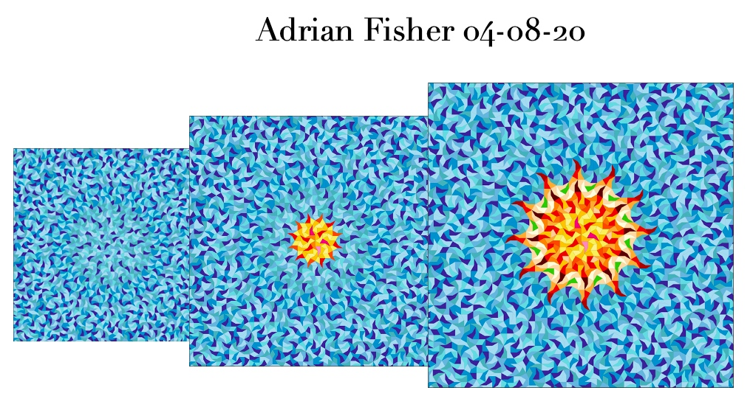

multimedia for editorial use here

The Art & Culture without Borders Foundation makes an urgent appeal for help for their #SOSBEIRUT initiative.

British artist, Adrian Fisher, donates his art work transformed into a scarf, printed on pure mulberry silk

Last August 4, the Lebanon capital, Beirut, was devastated by massive explosions in the port. It is known that at the least 100 people died and 4,000 were injured by the explosions. Before this tragedy, Lebanon was already suffering, plagued by corruption and political and social unrest and an economy at one of their worst moments since the tragic civil war.

The Art & Culture without Borders decided to take measures to help support the population of Beirut and provide funds to help the recovery of the city and give people a chance to hope . ACWB is committed to raising money for the following organizations: Ghina, Beit El Baraka, Lebanon Needs, Nusaned, Medonations, Beit El Diafi.

Award-winning British artist Adrian Fisher, recently awarded an MBE by Queen Elizabeth II, has donated a number of works to the foundation. The geometric paintings he created in shades of blue feature an abstract explosion, wheels of motion, and a spiral action in a burst of motion. These designs were transformed into a wonderful scarf, printed on pure mulberry silk to create a beautiful and collectible garment, to be worn around the neck, tied to a bag, or framed as an artwork. The scarves have been printed as a limited edition, only 120 pieces will be created. The silk scarf also includes a photographic print of the original painting that Adrian Fisher created exclusively for ACWB. An exquisite and memorable item that will quickly become a collector's item. The original paintings will soon be available for purchase through ACWB.

Presented in a specially designed box, the scarf will make a special Christmas present and can be preordered from the ACWB web.

The Foundation appreciates the time you to devote to publish this news and encourages you to let your friends. Without your generous support, the Foundation will be unable to support the NGO’s who need these funds to help reconstruct Beirut.

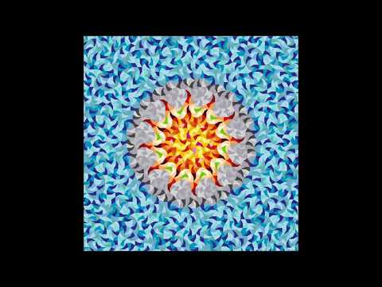
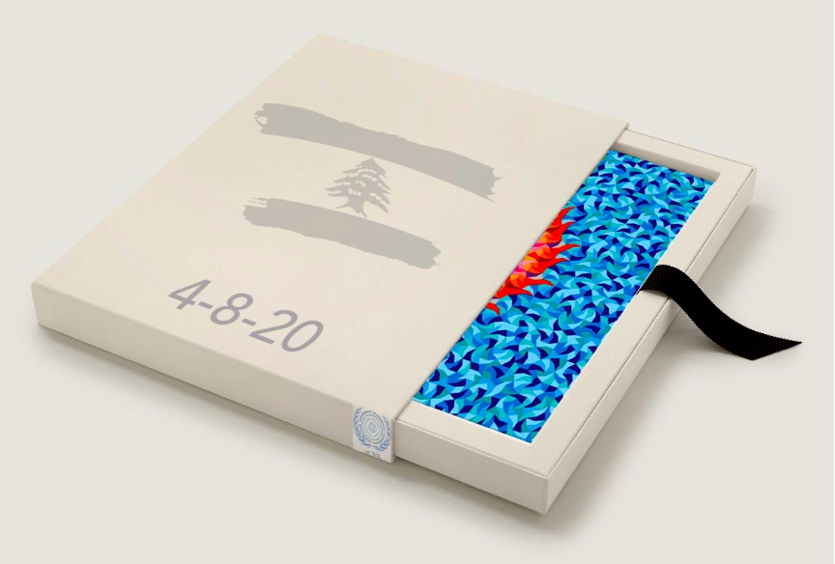
Box specially designed by Adrian Fisher

Shop on line: https://artculturewb.org/producto/donated-for-the-acwb-sos-beirut-gift-boxes/

Video: https://youtu.be/7o1tpKQBCQA

More about the artist https://www.mazemaker.com/

MORE INFORMATION:

Carlos Mundy: 34 675 851121 mondaye@artculturewb.org
y comunicacion@artculturewb.org

